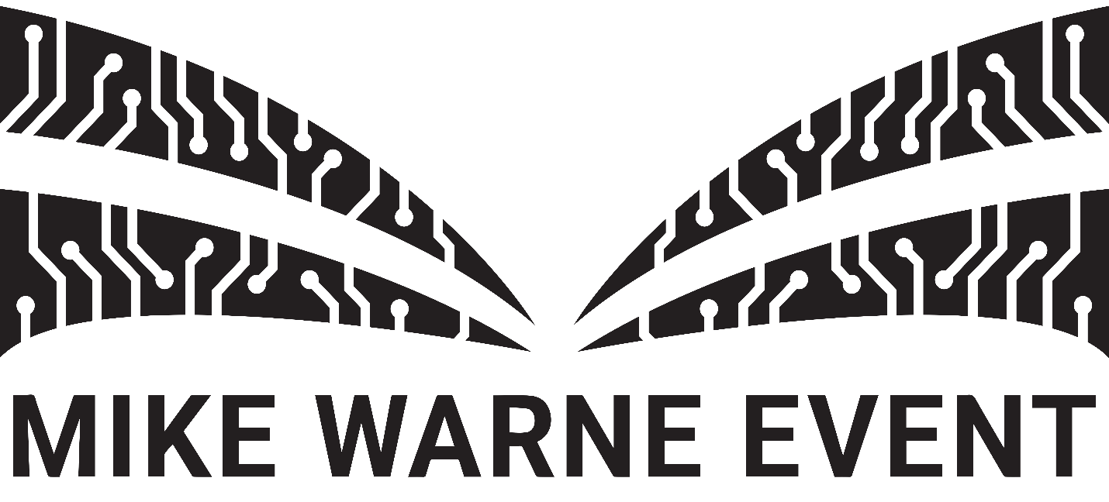

Immersive technology: the future of marketing
01 March 2017

The Mike Warne Event 2017 will be focusing on the use of Virtual Reality (VR) in the marketing industry. With VR and other forms of immersive technology continuing to grow in popularity, the question is how can we, as marketers, create measurable results with strategic use of these technologies?

The Mike Warne Event will bring together VR industry leaders to address current industry challenges, trends, and share first-hand experience integrating these tactics into Marketing campaigns. The event, hosted by Bournemouth University and organised by BA (Hons) Marketing, under graduates will be introduced by Chris Daly, Chief Executive of CIM. Speakers include:

Deciphering VR
Dean Johnson, Head of Innovation, Brandwidth
As an accomplished design leader, writer, presenter and BBC tech pundit, Dean is currently shaping the future of Virtual Reality (VR) as Head of Innovation at Brandwidth, a creative brand engagement agency using VR with some of the world’s biggest companies. Through his experience speaking on the topic of VR at events such as TEDx Athens and as co-host of the world’s first live-action VR series #StereocastVR, Dean continues to push the boundaries of VR further than ever before. At the Mike Warne Event, Dean will be sharing his expertise during an introduction into the capabilities of VR and the unique opportunities this technology can offer Marketers.

VR: Here and Now

Samantha Kingston, Client Director, Virtual Umbrella

Samantha is currently an award-winning Client Director at Virtual Umbrella, a Marketing and PR specialist agency working exclusively in the VR industry. Whilst Virtual Umbrella has only been established in the Tech industry for the past two years, the agency has already established themselves as leaders in the VR field through their work with companies such as Leo Burnett, Uber, Lipton Ice Tea, and a variety of agencies and game companies. Outside of her role at Virtual Umbrella, Samantha has a proactive voice within the VR community and for Women in Tech where she is often present as a moderator on panels on equality in the workplace. Samantha will be presenting VR from the client’s perspective through a range of VR case studies, including the impact this has on Marketers’ approach VR.

VR: The Future Forecast

Cathy White, Founder, CEW Communications

Acknowledged by PR Week as a ‘Rising Star’ in the tech industry, Cathy has worked on international campaigns in a range of sectors across the Tech space including some of Europe's leading startups such Esprit, Transferwise and Etsy. As the Founder at CEW Communications she specialises in accelerating the growth of digital startups. Cathy is also an organiser for the networking group GeekGirl Meetup UK, as well as the host of GeekGirlMeets, the podcast series interviewing rising women in Tech. In her talk at the Mike Warne Event, Cathy will be revealing how companies are currently adopting VR in Marketing across a wide range of industries and ultimately what this means for the future of VR.

